**23CSE111**

**OBJECT ORIENTED PROGRAMMING**

**LAB REPORT**



**Department of Computer Science Engineering**

**Amrita School of Computing**

**Amrita Vishwa Vidyapeetham, Amaravati Campus**

**Name: P. LIKITHA LEKHYA**

**Verified By Roll No: 24240**

**WEEK 01**

**PROGRAM-1:**

**AIM:** Download and Install Java Software

**PROCEDURE:**

**Step 1: Download JDK 21**

1. Open your web browser and go to the Oracle JDK Downloads page
2. Scroll down to the Java SE Development Kit 21 section.
3. Choose the Windows x64 Installer version.
4. Click on Download, then Wait for the download to complete

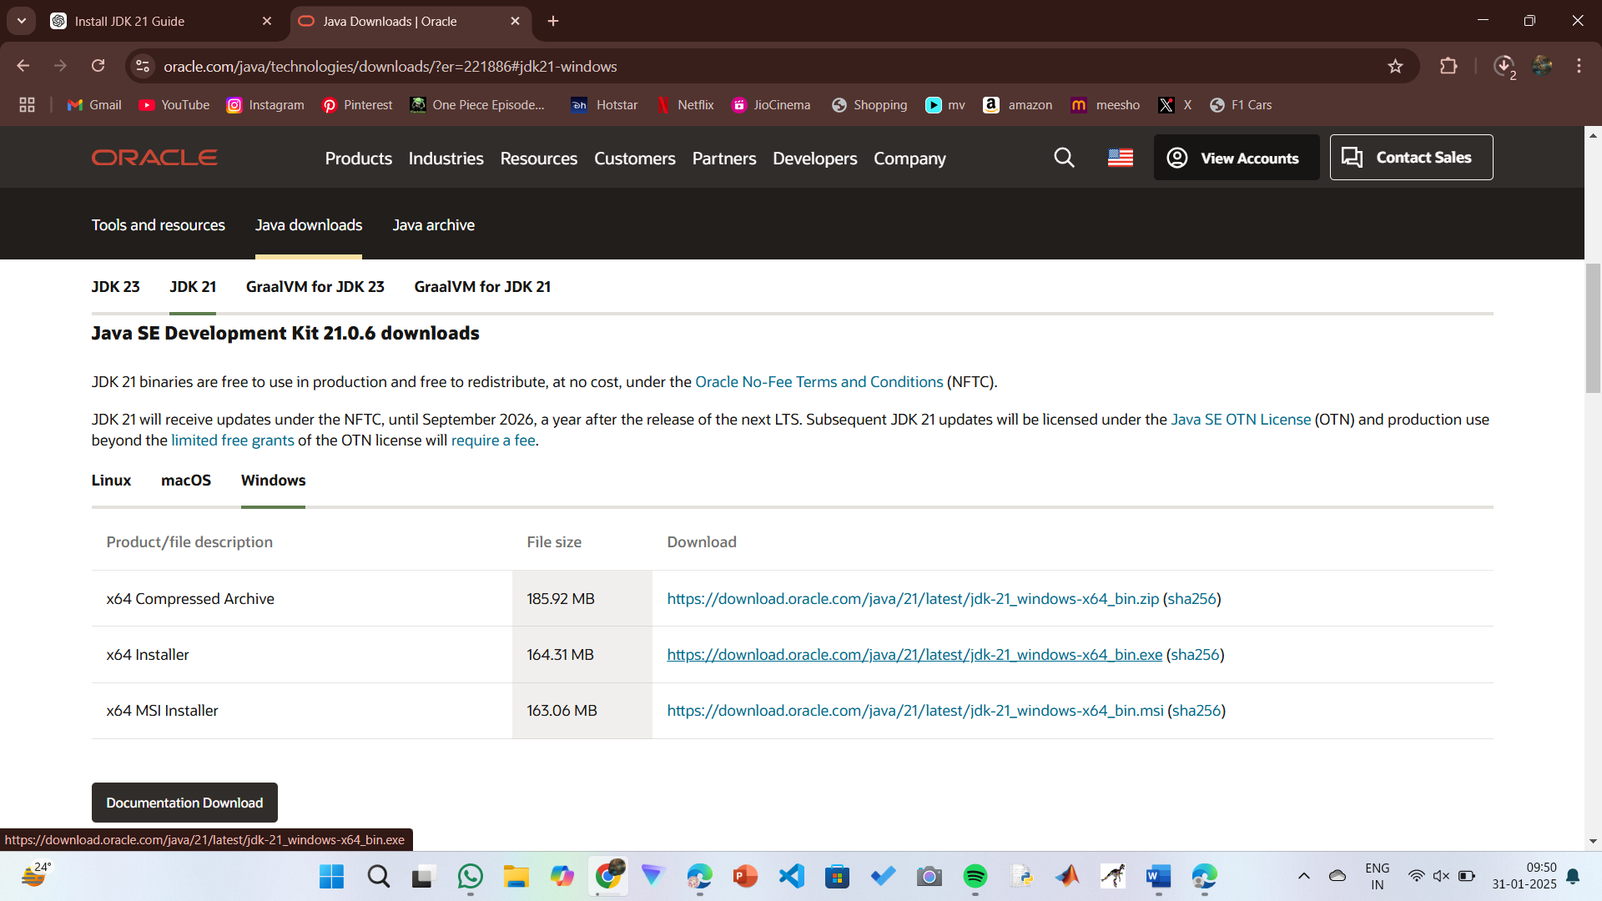

**Step 2:** **Install JDK 21**

1. Locate the downloaded jdk-21_windows-x64_bin.exe file.
2. Double-click to launch the installer.
3. Click Next on the setup wizard.
4. Choose the installation path (default is C:\Program Files\Java\jdk-21).
5. Click Next, then click Install.
6. Wait for the installation to complete.
7. Click Close once the installation is finished.

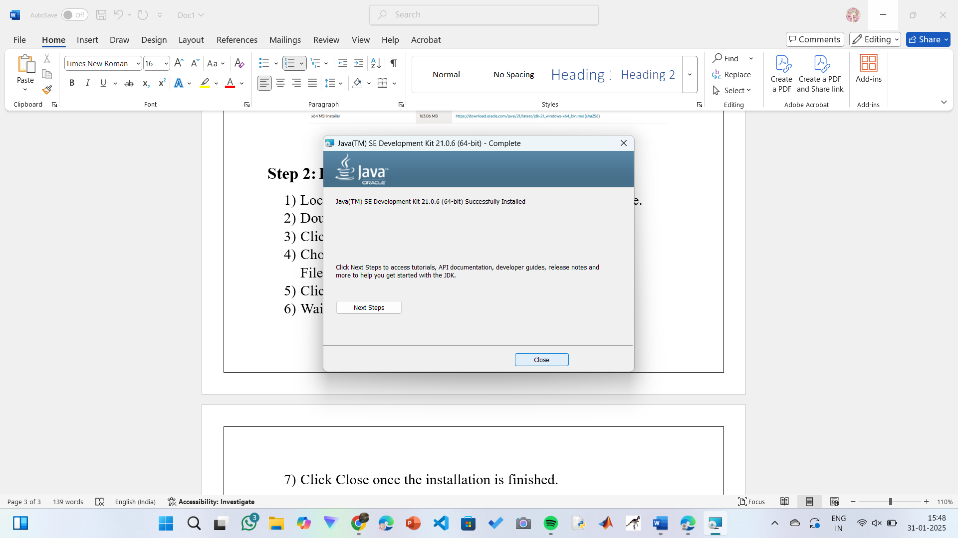

**Step 3: Setting up the path**

1) Go to “Windows C” Drive on Desktop

2) Choose Program Files, select Java, then JDK 21, then select Bin.

3) Select and copy the path at the address bar.

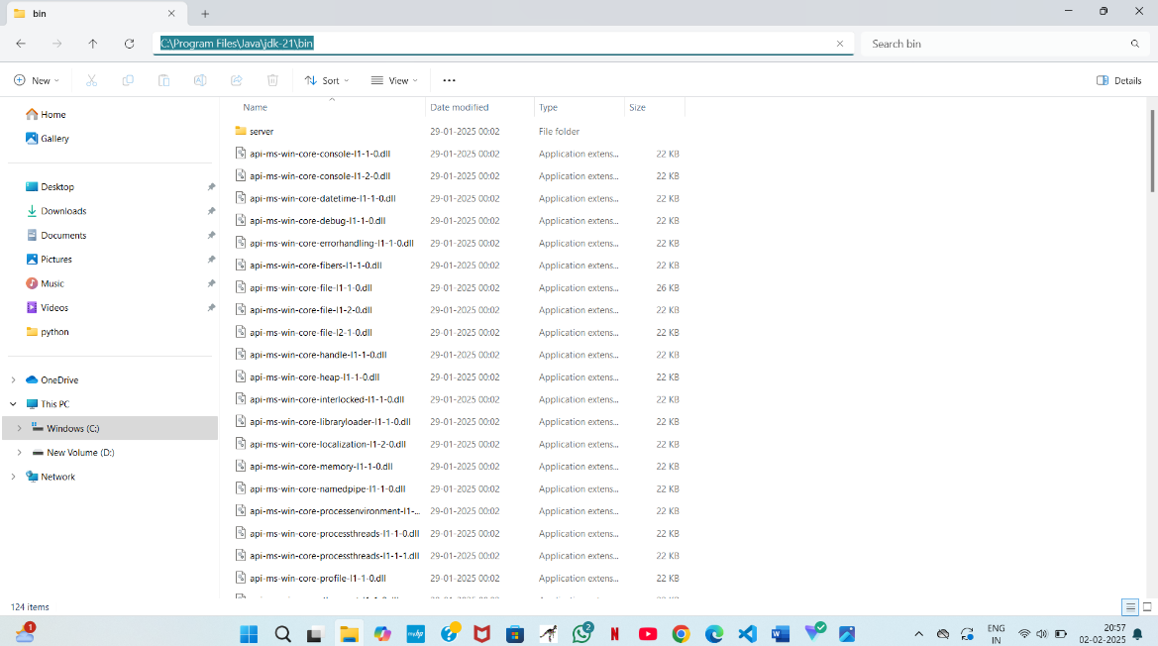

**Step 4: Open System Properties**

1. Press Windows + R, type sysdm.cpl , and click Ok-
2. The System Properties window will open.
3. Navigate to the Advanced tab.
4. Click on Environment Variables at the bottom.

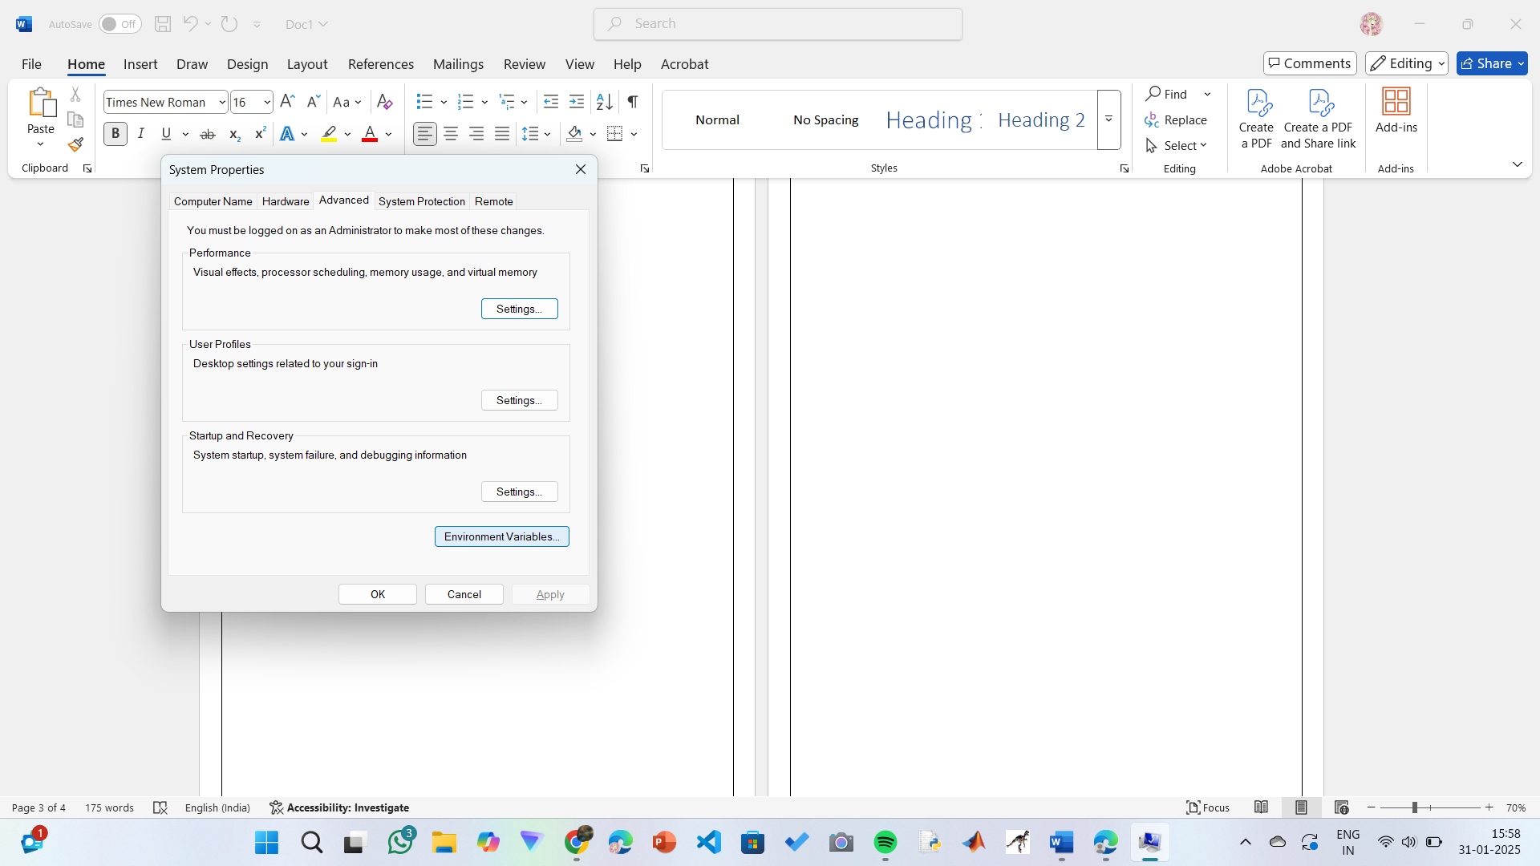

**Step 5: Set JAVA_HOME**

1)Under System Variables, click New.

2)Set the Variable name as JAVA_HOME.

3)Set Variable value as C:\Program Files\Java\jdk-21 (or your installation path).

4)Click OK.

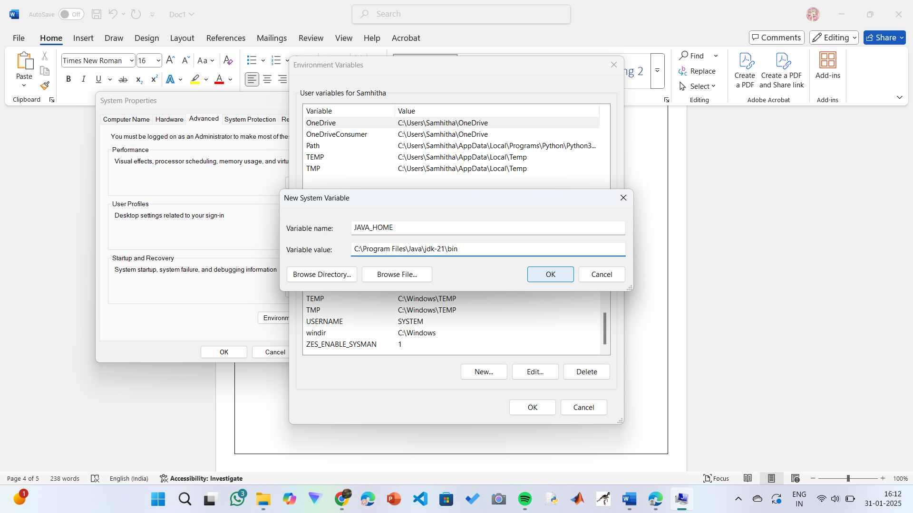

**Step 6: Update PATH Variable**

1)In System Variables, find Path and click Edit.

2)Click New and add: C:\Program Files\Java\jdk-21\bin

3)Click OK to save.

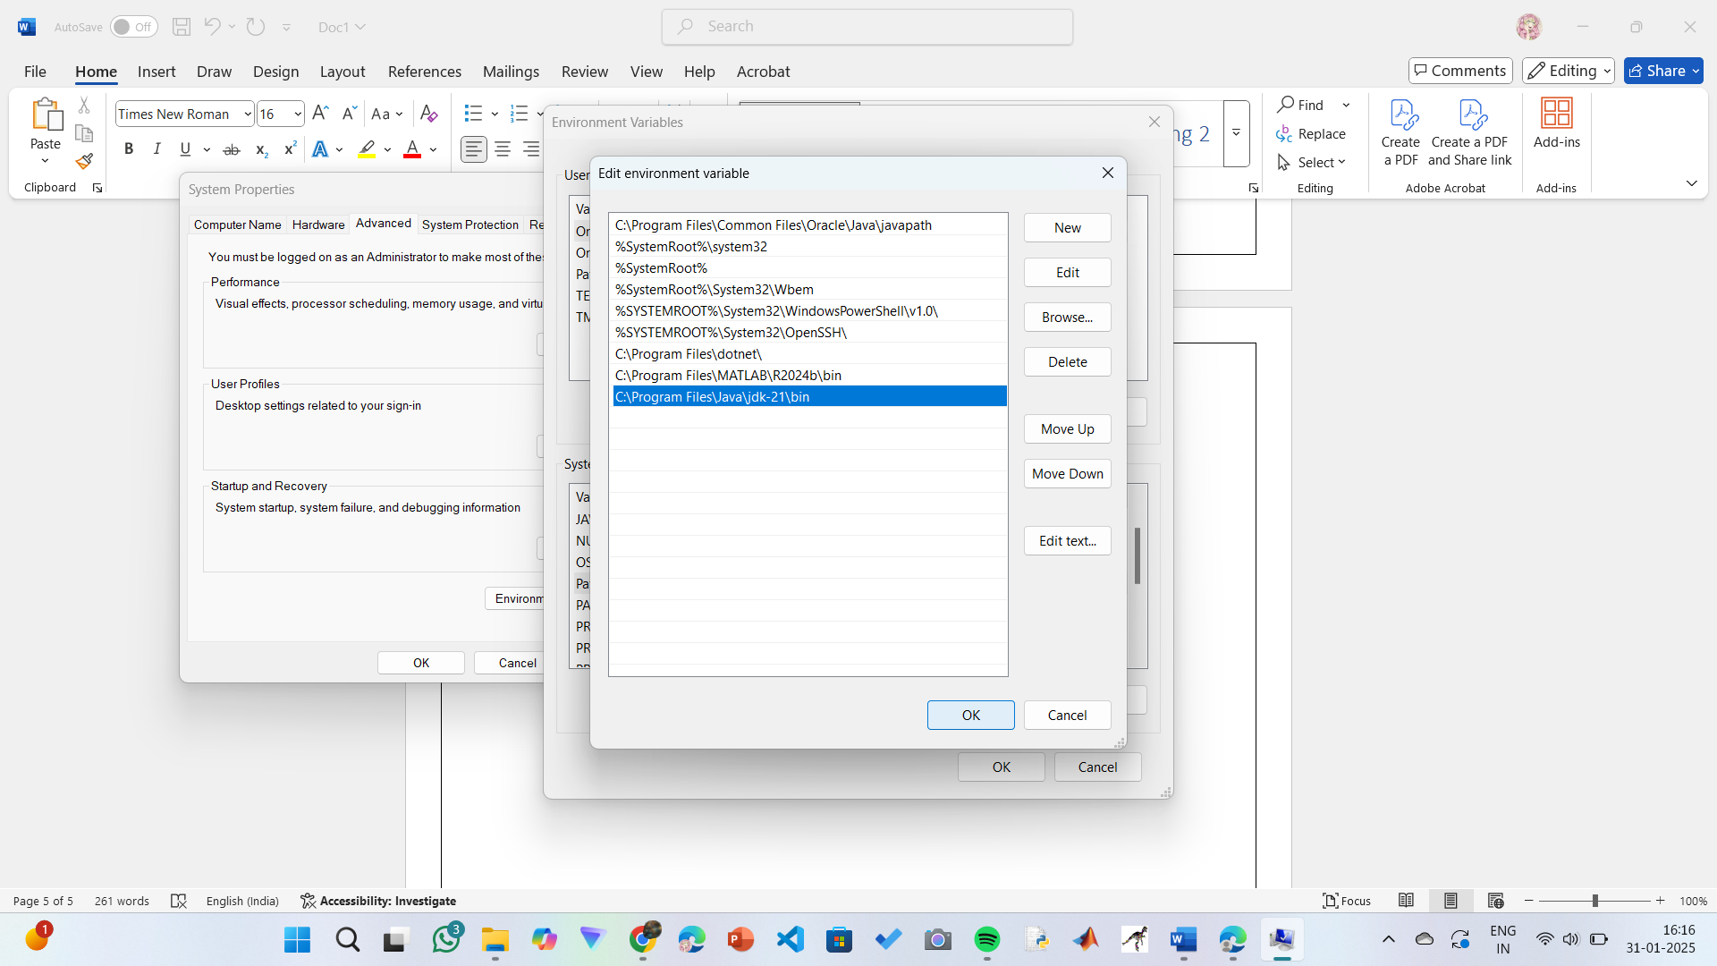

**Step 7:Verify Installation**

1. Open Command Prompt.
2. Type the following command: **java --version** and press Enter.

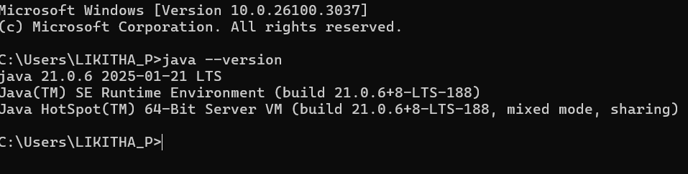

1. To check the java compiler type: **javac –version.**

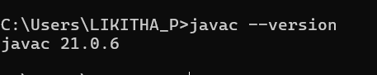

**PROGRAM-2:**

**AIM:** Write a Java program to print the message “Welcome to Java Programming.”

**CODE:**

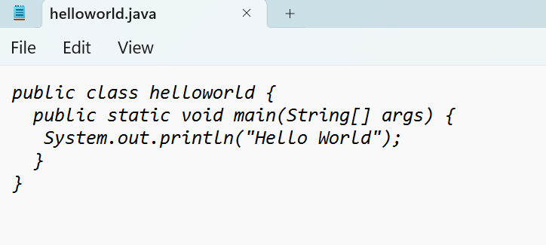

**OUTPUT:**

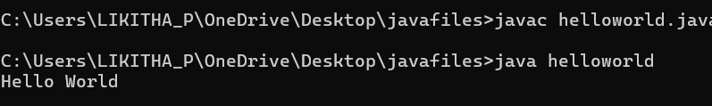

**ERRORS:** None found

**PROGRAM-3:**

**AIM:** Write a Java Program that prints Name, Roll No, Section of a student.

**CODE:**

**STUDENT DETAILS:**

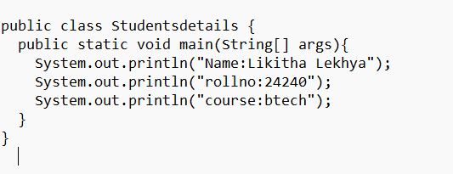

**OUTPUT:**

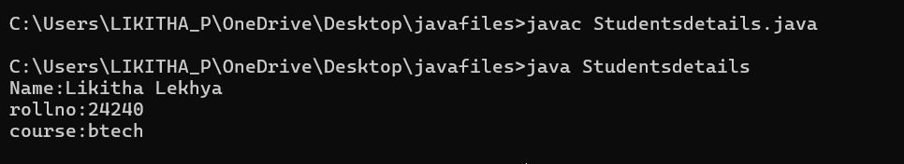

**ERROR TABLE:**

|  |  |
| --- | --- |
| **Code Error** | **Code rectification** |
| 1. writing small “S”in place of”S”   In system.out.println()  2)not giving strings to the name and scetion | 1. code is rectified by keeping capital “S” 2. Giving strings to name and section |

**IMPORTANT POINTS:**

1. When printing the statements, everything should be inside double quotes.

**WEEK-2:**

**1.AIM:** Write a Java Program for calculating area of rectangle

**PROGRAM:**

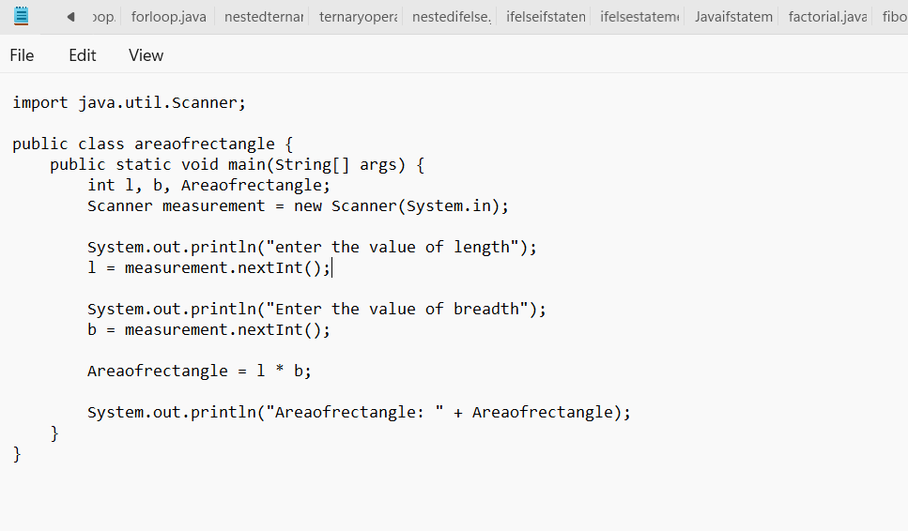

**OUTPUT:**

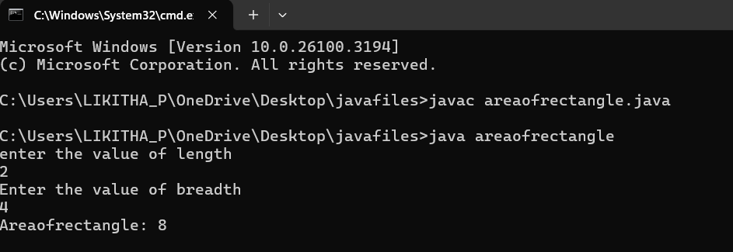

**ERROR TABLE:**

|  |  |
| --- | --- |
| **Code Error** | **Code rectification** |
| 1.While using for iteration, not giving the conditions correctly.  2.Declaring the data type as double instead of int. | 1.We should give iterative statements correctly.  2.We should give the data type as int for integers. |

**IMPORTANT POINTS:**

1.Area of a rectangle is area = l*b, where

L = length of a side of the rectangle,

B= breadth of a side of the rectangle.

2.Here, we must be sure that all the expressions/conditions inside for the for loop must be given correctly.

**2.AIM:** Write a Java Program for calculating simple intrest

**PROGRAM:**

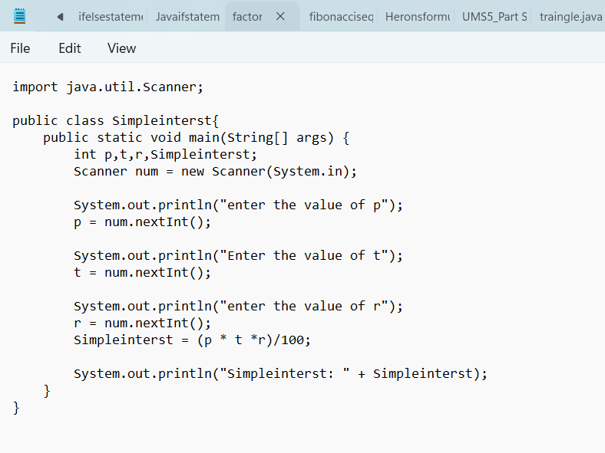

**OUTPUT:**

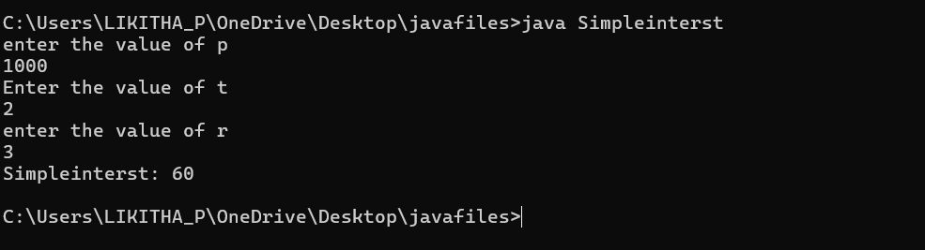

**ERROR TABLE:**

|  |  |
| --- | --- |
| **Code Error** | **Code rectification** |
| 1.Giving space between next and Double.  2.Not giving parenthesis after closing the input. | 1.Should not give space between next and Double.  2.We must put parenthesis after closing the input. |

**IMPORTANT POINTS:**

1.Simple interest formula is: (p*t*r)/100, where:

P: Principal amount

R: Rate of interest

T: Time period

2.The data type double indicates the floating points in the integers.

3.The line “import java.util.Scanner” indicates:

Import: tells the java compiler that we want to use a specific class or package in your code.

Java.util : This is the package that contains utility classes for Java programming, including the “Scanner” class.

Scanner: this is the class that allows you to read input from the keyboard.

**3.AIM:** Write a Java Program for finding factorial of a number

**PROGRAM:**

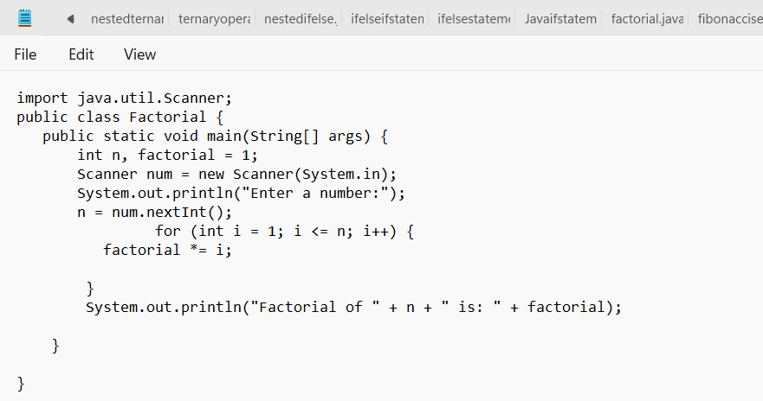

**OUTPUT:**

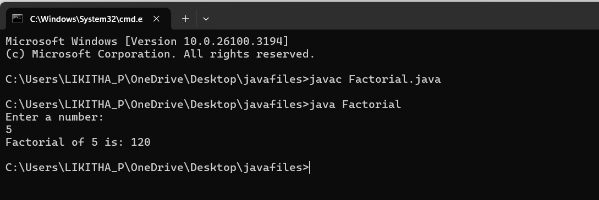

**ERROR TABLE:**

|  |  |
| --- | --- |
| **Code Error** | **Code rectification** |
| 1.While using for iteration, not giving the conditions correctly.  2.Declaring the data type as double instead of int. | 1.We should give iterative statements correctly.  2.We should give the data type as int for integers. |

**IMPORTANT POINTS:**

1.While the for loop the data inside the parenthesis indicates the Initial expression

Test expression and

Update expression.

2.Here “factorial*=I” means factorial = factorial*I.

3.Here we are using the data type “int” just to calculate the integer values and it doesn’t support floating points.

**4.AIM:** Write a Java Program for finding Fibonacci series of a number

**PROGRAM:**

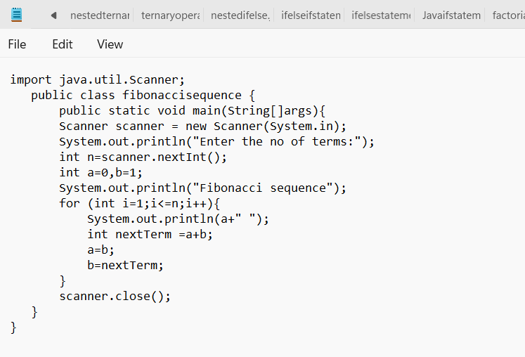

**OUTPUT:**

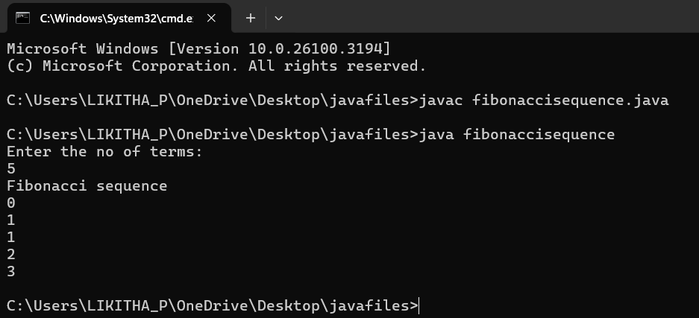

**ERROR TABLE:**

|  |  |
| --- | --- |
| **Code Error** | **Code rectification** |
| 1.Giving space between next and Double.  2.Not giving parenthesis after closing the input. | 1.Should not give space between next and Double.  2.We must put parenthesis after closing the input. |

**IMPORTANT POINTS:**

1.In the Fibonacci sequence, the sum value is given to the second variable, and the value of the second variable is given to the first variable.

2.This process is repeated a certain number of times until the conditions are met.

**5.AIM**: Write a Java Program for calculating area of triangle using herons formula

**PROGRAM:**

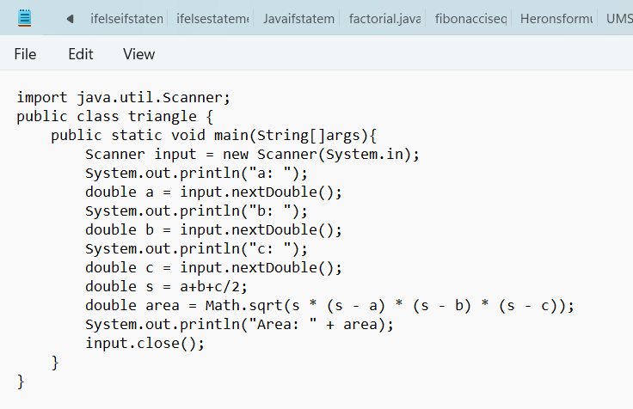

**OUTPUT:**

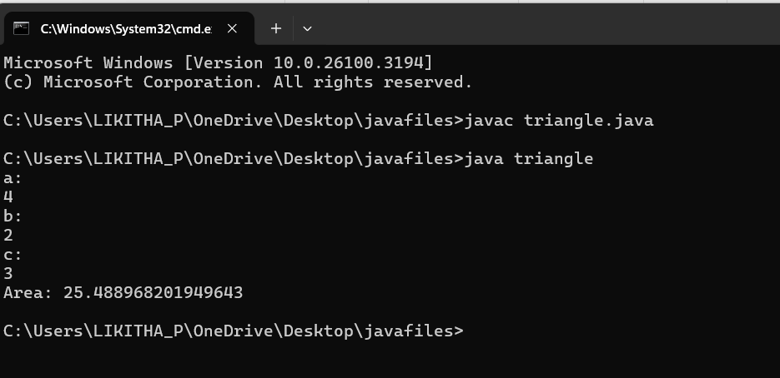

**ERROR TABLE:**

|  |  |
| --- | --- |
| **Code Error** | Code rectification |
| 1.While printing the variable not giving + sign.  2.Not closing the scanner. | 1.We should give correct indentation.  2.Closing the scanner is must. |

**IMPORTANT POINTS:**

1.Here, we’re finding the area of a triangle using heron’s formula.

2.Heron’s formula for finding a triangle is:

S = (a +b +c)/2

Where S is the semi-perimeter of the triangle.

Now the area formula is:

Area = sqrt(s*(s-a)*(s-b)*(s-c)).

**6. I.) AIM:** Write a Java Program for conversion from Celsius to farenheit

**PROGRAM:**

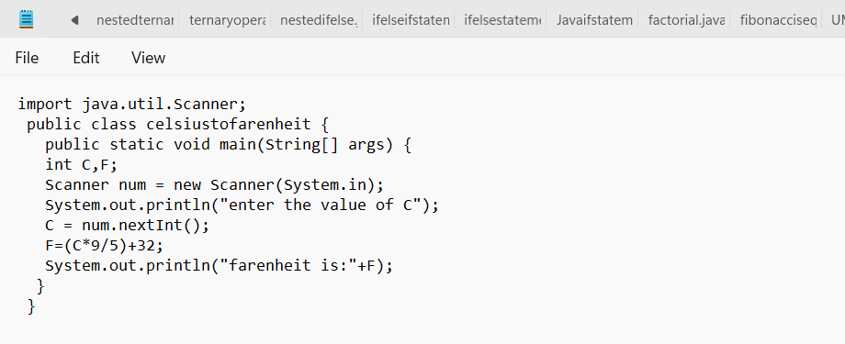

**OUTPUT:**

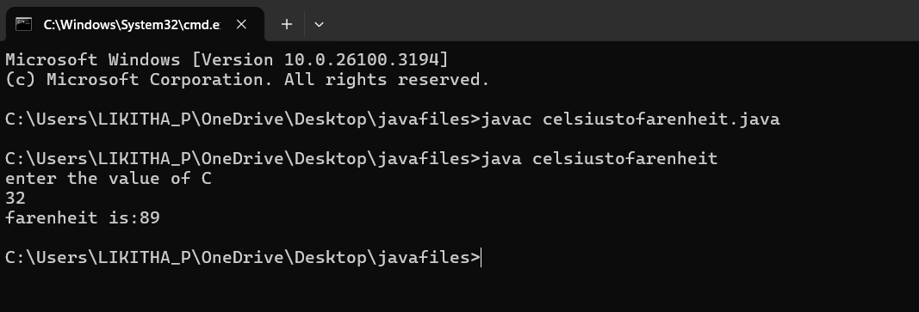

**II.) AIM:** Write a Java Program for conversion from farenheit to celsius

**PROGRAM:**

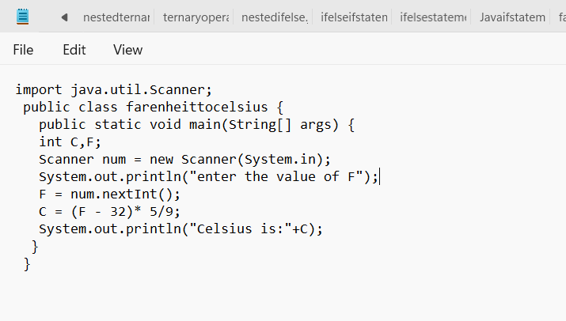

**OUTPUT:**

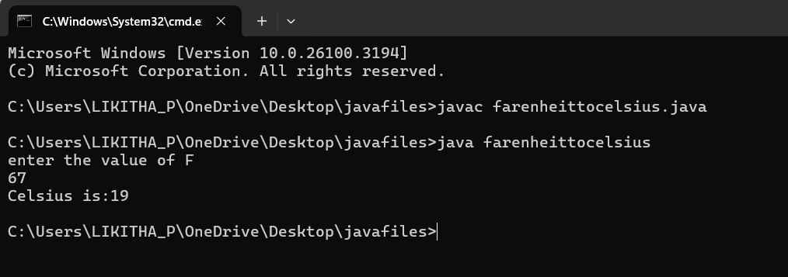

**ERROR TABLE:**

|  |  |
| --- | --- |
| **Code Error** | **Code rectification** |
| 1.While printing the variable not giving + sign.  2.Not closing the scanner. | 1.We should give correct indentation.  2.Closing the scanner is must. |

**IMPORTANT POINTS:**

1.The formula to convert a Fahrenheit to Celsius is

Celsius = (Fahrenheit-32)*5/9

2.The formula to convert a Celsius to Fahrenheit is

Fahrenheit = (Celsius*9/5)+32.

3.The line “Scanner input = new Scanner(System.in),” tends to create a new Scanner object named “input” that reads input from the standard input stream (System.in), like keyboard.

**WEEK -3:**

**1.AIM:** To create java program with following instructions :

1.Create a class with name Car

2.Create four attributes named car_color,car_brand, fuel_type, mileage

3.Create these methods named start(),stop(),service()

4.Create the objects named car, car1,car2

**PROGRAM:**

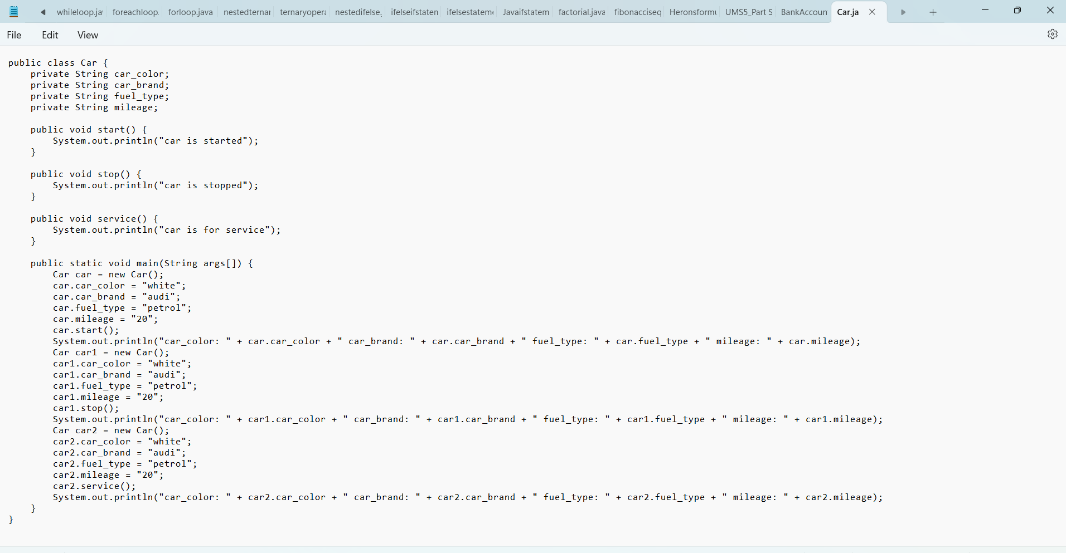

**OUTPUT:**

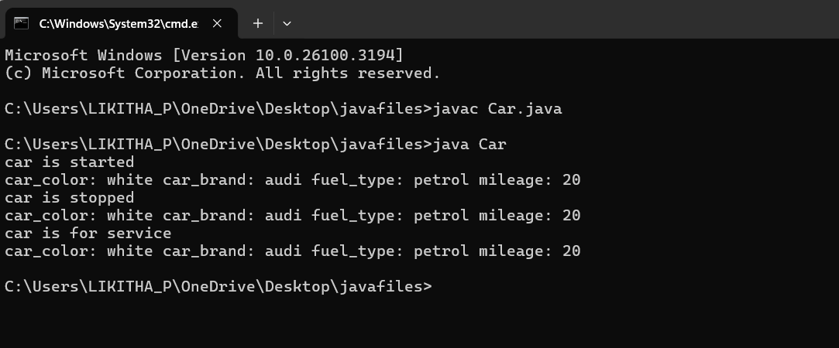

**2.AIM:** To create a class BankAccount with methods deposit() and withdraw() . create two subclasses savingsaccount and checkingaccount override the withdraw () method in each subclass to impose different withdrawal limits and fees

**PROGRAM:**

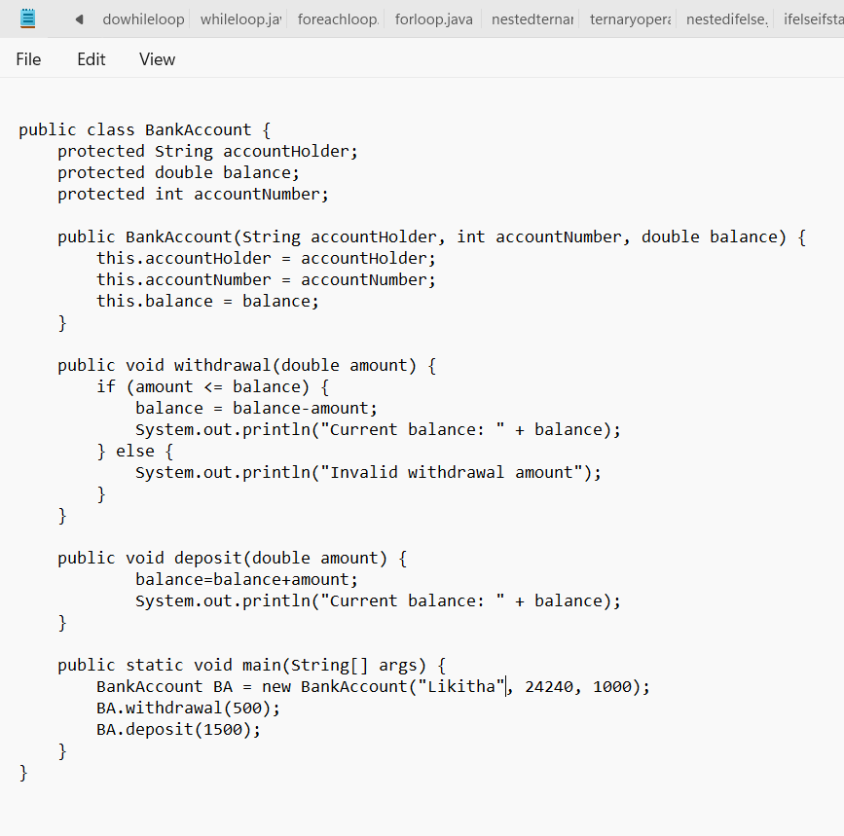

**OUTPUT:**

